EXP 17:

AIM: Design TM using simulator to accept the input string Palindrome ababa

INPUT:

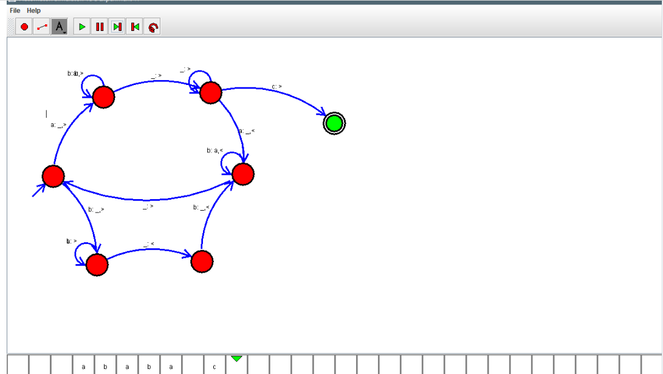

OUTPUT:



RESULT:Design TM using simulator to accept the input string Palindrome ababa is verified